Creating a Visual Basic Application Containing Multiple Forms
Before we can look at hiding and showing Forms we first need to create an application in Visual Studio which contains more than one form. Begin by starting Visual Studio and creating a new Windows Application project called vbShowForm
Visual Studio will prime the new project with a single form. Click on the Form to select it and, using the Properties panel change the Name of the form to mainForm. Next we need to add a second form. To do this, click on the Add New Item in the Visual Studio toolbar to invoke the Add New Item window:
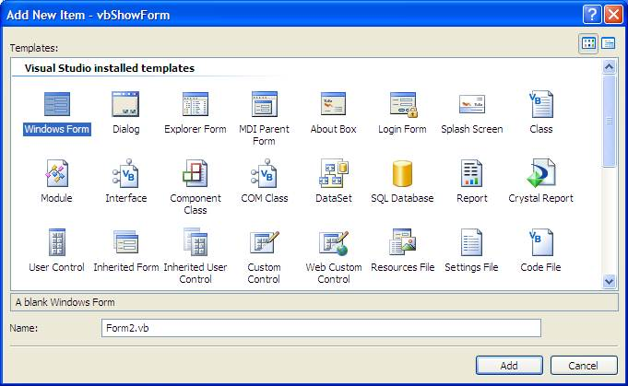
The Add New Item window allows new items of various types to be added to the project. For this example we just need to add a new Windows Form to our application. With Windows Form selected in the window click on Add. Visual Studio will now display an additional tab containing the second form:
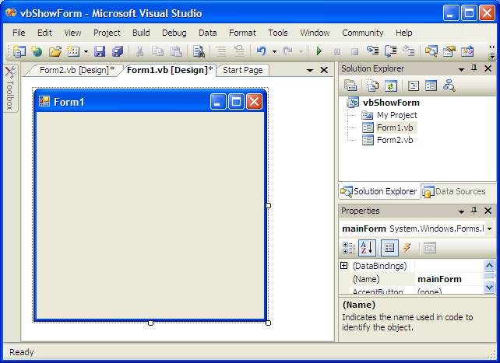
Switch between the two forms by clicking on the respective tabs. With Form2 visible click on the form and change the name of the form in the Properties panel to subForm.
Now that you have created two forms, add a Button to each form by displaying the Toolbox and dragging a Button onto each form.
Now that we have created an application with two forms the next step is provide a mechanism for hiding and showing subForm. Before doing that, however, we first need to understand the difference between modal and non-modal windows.

Understanding Modal and Non-modal Forms
A Windows form can be displayed in one of two modes, modal and non-modal. When a form is non-modal it means that other forms in the other forms in the application remain accessible to the user (in that they can still click on controls or use the keyboard in other forms).
When a form is modal, as soon as it is displayed all other forms in the application are disabled until the modal dialog is dismissed by the user. Modal forms are typically used when the user is required to complete a task before proceeding to another part of the application.

Opening a form
Before you can open (or close) a form, you need to know the specific name of the form you want to open or close. The Solution Explorer window lists the names of all the forms that make up your Visual Basic .NET program, such as a form named frmMain.vb.
After you know the name of the form that you want to display, you need to use BASIC command to open the form, such as the following:
Dim oForm As FormName
oForm = New FormName()
oForm.Show()
oForm = Nothing

Hiding Forms in Visual Basic
There are two ways to make a form disappear from the screen. One way is to Hide the form and the other is to Close the form. When a form is hidden, the form and all its properties and settings still exist in memory. In other words, the form still exists, it is just not visible. When a form is closed, the form is physically deleted from memory and will need to be completely recreated before it can be displayed again.
To hide a form it is necessary to call the Hide() method of the form to be hidden. Using our example, we will wire up the button on the subForm to close the form. Click on the tab for the second form (the subForm) in your design and double click on the button control to display the Click event procedure.
One very important point to note here is that the button control is going to hide its own Form. In this case, the event procedure must reference Me instead of referencing subForm by name. With this in mind, modify the procedure as follows:
Private Sub Button1_Click(ByVal sender As System.Object, ByVal e As System.EventArgs)
Handles Button1.Click

Me.Hide()

End Sub

Closing Forms in Visual Basic
As mentioned in the previous section, in order to remove a form both from the display, and from memory, it is necessary to Close rather than Hide it. In Visual Studio double click, once again, on the button in subForm to view the Click event procedure. Once again, because the button is in the form we are closing we need to use Me instead of subForm when calling theClose() method:
Private Sub Button1_Click(ByVal sender As System.Object, ByVal e As System.EventArgs)
Handles Button1.Click

Me.Close()

End Sub
When the subForm button is pressed the form will be closed and removed from memory.

A MsgBox() and InputBox() Overview
You use input boxes and message boxes when you need to ask the user questions or display error messages and advice to the user. For example, suppose the user is to enter a sales code of A, B, or C to indicate a discount to be used in a total calculation. Users don't always know what's expected of them, so a message box can pop up when the user enters a bad value, and the message box can explain that the user needs to enter only A, B, or C. If the user enters an invalid code, your program could display an error message such as the one shown inFigure 6.2.
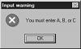
A message box can tell the user what to do.
A message box is a dialog box you display to give the user information. An input box is a dialog box you display to ask the user questions. A message box is typically used to display a short single sentence message to the user. Program execution continues after the user acknowledges the message box. An input box, on the other hand, can be thought of as a message box with a text box. An input box displays a prompt to the user and obtains text input from the user.

A message box is a dialog box you display to give the user information. An input box is a dialog box you display to ask the user questions. A message box is typically used to display a short single sentence message to the user. Program execution continues after the user acknowledges the message box. An input box, on the other hand, can be thought of as a message box with a text box. An input box displays a prompt to the user and obtains text input from the user.
Input boxes always give the user a place to respond with an answer. In Figure 6.3, the input box is asking the user for the name of a server.
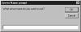
Input boxes get user information

Multiple Document Interface (MDI)
MDI (Multiple Document Interface) is a Microsoft Windows programming interface for creating an application that enables users to work with multiple documents at the same time. Each document is in a separate space with its own controls for scrolling. The user can see and work with different documents such as a spreadsheet, a text document, or a drawing space by simply moving the cursor from one space to another.
MDI is a popular interface because it allows you to have multiple documents (or forms) open in one application. Examples of MDI applications include Microsoft Word, Microsoft Excel, Microsoft PowerPoint®, and even the Visual Studio integrated development environment itself. Each application consists of one (or more) parent windows, each containing an MDI client area—the area where the child forms (or documents) will be displayed.

Uses of MDI
You'll use MDI most often in applications where the user might like to have multiple forms or documents open concurrently. Word processing applications (like Microsoft Word), spreadsheet applications (like Microsoft Excel), and project manager applications (like Microsoft Project) are all good candidates for MDI applications. MDI is also handy when you have a large application, and you want to provide a simple mechanism for closing all the child forms when the user exits the application.

DAO (Data Access Objects) definition
DAO (Data Access Objects) is an application program interface (API) available with Microsoft's Visual Basic that lets a programmer request access to a Microsoft Accessdatabase. DAO was Microsoft's first object-oriented interface with databases. DAO objects encapsulate Access's Jet functions. Through Jet functions, it can also access other Structured Query Language (SQL) databases.

